
Company
Logotype

Cone Beam Computed Tomography- Report



Porur Dental X-rays & CBCT

Patient Name : Mr. Ramesh | Date of Report : 19.05.2024
Age/ Gender : 70 years/ Male | Region of Interest : CBCT Full Skull
Referring doctor: Dr. Dany. A | Indication : Implant assessment
Clinical Notes: Nil
PATIENT INFORMATION

CBCT- Full Skull provided
CBCT – IMAGE DETAILS

RADIOGRAPHIC INTERPRETATION

- Complete loss of crown and root structure in relation to 15, 16, 17, 18, 23, 24, 25, 26, 31, 32, 33, 34, 35, 36, 37, 38, 46.
- Root stumps in relation to 11, 12, 13, 14
- The alveolar ridge in relation to the maxillary and mandibular alveolar ridge is present with normal trabecular pattern.

IMPLANT ASSESSMENT

 | 11 region | 12 region | 13 region | 14 region | 21 region | 22 region | 23 region | 24 region
Sub-Crestal
Mid- Crestal
Distance between the alveolar ridge and Floor of the Nasal cavity (in mm)

 | 15 region | 16 region | 17 region | 25 region | 26 region | 27 region
Sub-Crestal (in mm)
Mid- Crestal (in mm)
Distance between the alveolar ridge and floor of the maxillary sinus (in mm)

 | 31 region | 32 region | 33 region | 34 region
Sub-Crestal (in mm)
Mid- Crestal (in mm)
Distance between alveolar ridge and the inferior border of mandible (in mm)

 | 41 region | 42 region | 43 region | 44 region
Sub-Crestal (in mm)
Mid- Crestal (in mm)
Distance between alveolar ridge and the inferior border of mandible (in mm)
 | 45 region | 46 region | 47 region
Sub-Crestal (in mm)
Mid- Crestal (in mm)
Distance between alveolar ridge and the inferior alveolar nerve canal (in mm)
Distance between alveolar ridge and the inferior border of mandible (in mm)

 | 35 region | 36 region | 37 region
Sub-Crestal (in mm)
Mid- Crestal (in mm)
Distance between alveolar ridge and the inferior alveolar nerve canal (in mm)
Distance between alveolar ridge and the inferior border of mandible (in mm)

RADIOGRAPHIC IMPRESSION

- Partially edentulous maxillary and mandibular arch.

Kindly correlate with clinical findings


IMAGES FOR REFERENCE

RECONSTRUCTED PANORAMIC VIEW

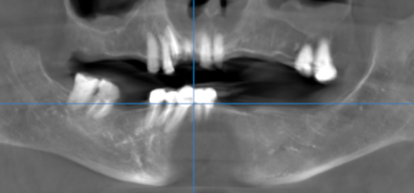

3-DIMENSIONAL VIEW

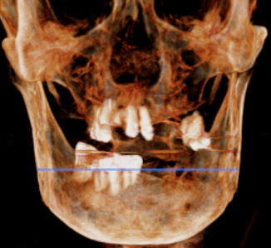

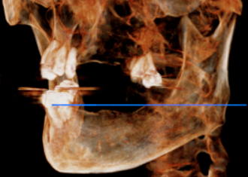

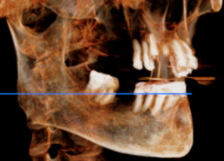

CROSS SECTIONAL VIEW

11 region

12 region
13 region
14 region
15 region
16 region
17 region
21 region
22 region
23 region
24 region
25 region
26 region
27 region
31 region
32 region
33 region
34 region
35 region
36 region
37 region
41 region
42 region
43 region
44 region
45 region
46 region
47 region

**** End of report ****

